**ATM Database System**

**Objective:**

This system allows users to make money transactions from one account to another. The users have to enter their account number and then they can access the main menu from where they can perform the action they desire.

Various functionalities including sending and receiving money, changing password, inquire about account balance. It is a flexible application and user-friendly. The front end has been designed using Java swing and database connectivity connects it to a database in MS Access. Due to the various advantages of Java like portability, security, robustness, this system has been designed in Java. This allows users to perform various ATM transactions online and even change their passwords in case of any emergencies. The various controls have been placed on different panels thus making it easy for user to make the best use of the software.

**Existing System:**

Manually performing transactions and other ATM related actions in the banks is not always possible. There may be cases of emergencies or public holidays which makes it impossible to gain access to these facilities at every time. Also it is time taking and exhaustive in case there is a long queue of customers at the bank or even at the ATM kiosk that are generally provided by banks at various places. Sometimes these kiosks are also out of order making it difficult for the customers to get their job done and also these cause waste of time.

**Proposed System:**

ATM database system provides user the option to access information about their accounts and make cash transactions and even change their passwords online. One does not have to be physically present at the bank or the kiosk to get their jobs done. This efficient and secure software lets users to sit in the comfort of their homes and access the various functionalities of the system. One can also check the balance in their account through this system and also make self transactions.

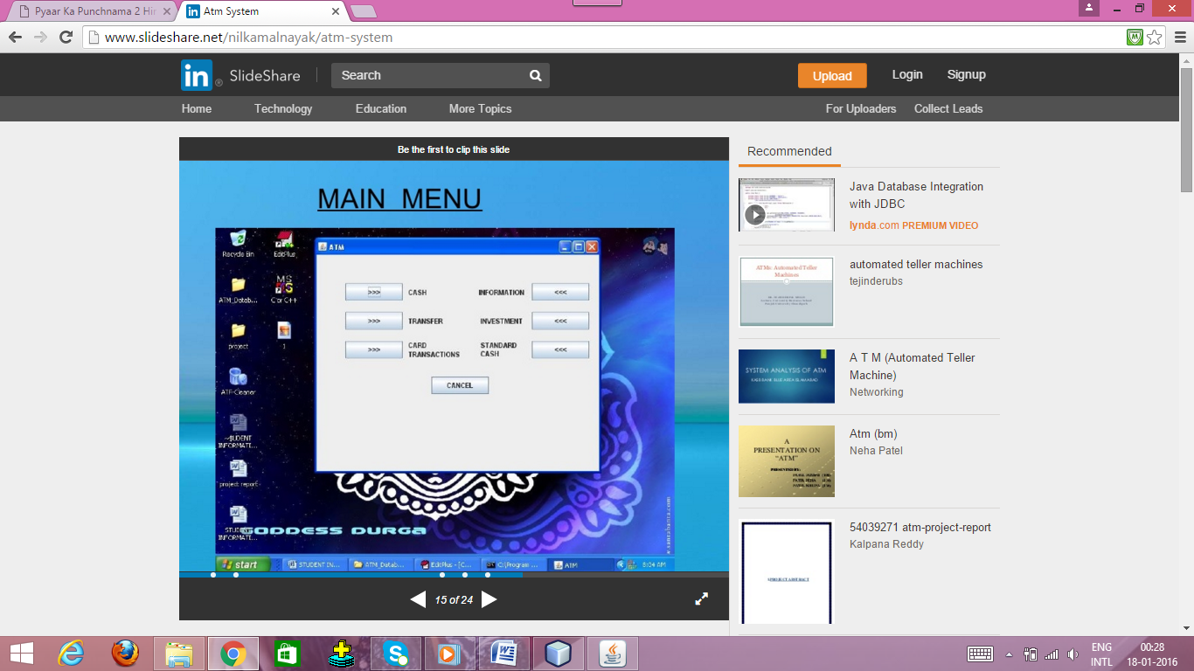

**Modules:**

1. Cash module:- This module shows the denominations of the money.
2. Transfer module:- This module lets users to transfer cash from one account to another. The inputs are the password of the sender and the receiver and the amount of money to be transferred.
3. Card transactions module:- This module has two sub-modules: Change password and dept paying.
   1. Change password:- This module allows the user to change his current password.
   2. Dept paying:- This module has been designed to pay debts or loans like credit debts, education debts, insurance debts, etc.
4. Standard Cash Module:- This module lets the user see the details of his account like name, password and the amount left after the standard deduction of a fixed amount.
5. Information Module:- This module lets the user see the remainder amount in his account after a transaction.

**Software Requirements**

* Eclipse

**Hardware Requirements**

* Hard Disk – 2 GB.
* RAM required – 1 GB (minimum)

**Technology Used**

* Java
* MS Access